

**MEMORANDUM**

**DATE: November 13, 2009**

**TO: Laboratory Group E**

**Tyler Conner, Margaret Marshall, Amos Deloy**

**FROM: Tony Butterfield**

**Engineering Training Supervisor**

**SUBJECT: Clear Heated/Cooled Stage**

Our lab is studying perfluoropentane microdroplets. These particles are to undergo a phase change from liquid to vapor in the body upon heating with focused ultrasound or radio waves, to therapeutic ends. We want to visualize these droplets and their transition to bubbles with light microscopy. However, the only heated stage we have is opaque and takes about 20 min to reach 50 °C from room temperature.

During the 1st project period, Group D characterized the first iteration of a clear stage design. In the 2nd project period Group E did preliminary work on developing a control system only meant to actively heat the stage. You may want to talk with them about their experience and findings, but your project will be significantly different. You are to incorporate both heating and cooling into the control of the stage temperature into the system.

I propose a fairly simple (and cheap) design, as shown the following figure.

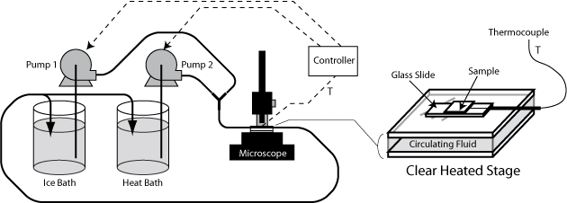

In this design, a fluid from a heat or ice bath is pumped between two clear plates, which make up the stage. On top of the stage will be the sample of interest. The controller will adjust the pump speed in order to compensate for the heat loss (or gain) that will occur in the stage (and tubing) exposed to room temperature. The temperature to be controlled is the temperature of the sample. You may alter this design if you feel some other may better suit our needs; however, discuss alterations with me before you commit to them to assure you do not violate some of the design objectives.

Your first task will be to assemble the system: the stage, pump, temperature bath, tubing, controller and thermocouples (you will likely want to take more than one temperature measurement). I will provide you with the needed materials and equipment. I suggest you program the controller to switch between sending the control signal to the hot and cold pump based on the error signal. Next you should conduct some appropriate tests to approximate the transfer function of the system.

Choose a control scheme (e.g. PI or PID) that will best give the ability to quickly and accurately reach a new temperature set point. Find apropriate control settings using the controller tuning method of your choice (however, use some formal method beyond mere trial and error). While we want as quick of a response as possible, our microdroplet emulsion is irreversibly temperature sensitive, and therefore it is important to avoid overshoot. Adjust the tuning parameters accordingly and report your recommendations.

It is very important that the temperature we control be as close to the temperature experienced by the microdroplet samples as possible. It is not possible, however, to insert a thermocouple into each sample. We have two main methods of preparing our samples: 1. The sample is injected into a microfluidic channel in a cyclo-olefin copolymer slide; 2. The sample is between a glass slide and glass cover slip, but the cover slip is raised to the height of a glass slide to allow for diffusion of droplets. I will show you these different methods.

Please use a test slide that will give us the most accurate temperature measurements for one of the sample preparation methods. Comment on any possible differences introduced by use of the different sample preparation methods.

Please contact me with any questions you may have, and I look forward to meeting with you regarding this project on or before Wednesday, November 18, 2009.